**Report of Sales and Orders Analysis**

Name : Ashwini Choudhary

Education: BTech(Computer Science)

Course: Business Analyst

Batch code: CX-96

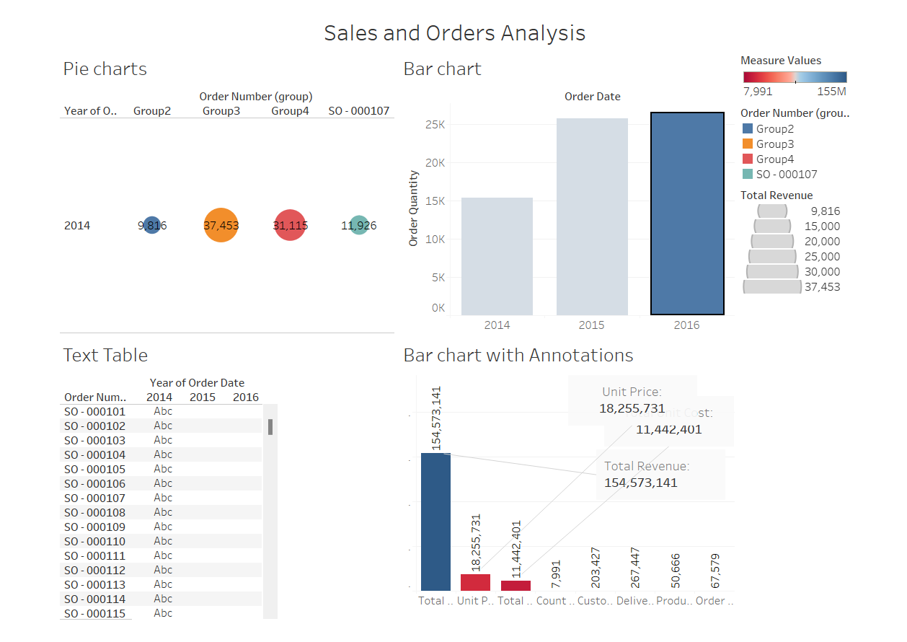

1. **Introduction:**

This report aims to analyze the sample sales and orders data provided. The dataset consists of various attributes such as OrderNumber, OrderDate, Ship Date, Customer Name Index, Channel, Currency Code, Warehouse Code, Delivery Region Index, Product Description Index, Order Quantity, Unit Price, Total Unit Cost, and Total Revenue. Through this analysis, we seek to extract insights into the sales patterns, customer behavior, and overall performance of the business.

1. **Methodology:**

The analysis will follow a structured approach comprising data preprocessing, exploratory data analysis, and visualization. Data preprocessing will involve cleaning the dataset, handling missing values, and ensuring data consistency. Exploratory data analysis will include descriptive statistics, distribution analysis, and correlation analysis. Visualization will be employed using charts and dashboards to present key findings effectively.

1. **Requirement Analysis:**

The primary requirements for this analysis include:

• Understanding sales trends over time

• Analyzing sales performance by customer segment, channel, and region

• Identifying top-selling products and their profitability

• Evaluating the effectiveness of pricing strategies and cost management

1. **Other Parameters depending upon the Projects:**

Additional parameters that may be considered depending on the project requirements include:

• Customer segmentation analysis

• Profit margin analysis

• Sales forecasting

• Comparison with industry benchmarks

• Customer satisfaction analysis

1. **Visualization:**

The following visualizations will be included in the analysis:

• Time series line chart showing sales trend over time

• Bar chart depicting sales performance by customer segment, channel, and region

• Pie chart illustrating product-wise sales distribution

• Scatter plot showcasing the relationship between unit price and total revenue

• Dashboard integrating all visualizations for comprehensive analysis

1. **Insights from the Charts as well as Dashboards:**

Insights derived from the visualizations and dashboards will include:

• Seasonal sales patterns and peak periods

• Revenue contribution from different customer segments and channels

• Geographic regions with highest and lowest sales volume

• Top-selling products and their contribution to overall revenue

• Correlation between unit price and total revenue, highlighting pricing impact on sales

1. **Conclusion:**

In conclusion, this analysis provides valuable insights into the sample sales and orders data, enabling informed decision-making for business optimization. By understanding sales trends, customer behavior, and product performance, the company can devise strategies to enhance profitability, improve customer satisfaction, and drive growth. Further analysis and refinement may be warranted to delve deeper into specific areas of interest and address evolving business needs.